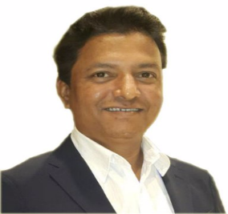
Mangesh S Thorat
| Mobile: +91-9113576255 | E-Mail: Sunmangesh@gmail.com|
|linkedin.com/in/mangeshsthorat |

| IT Datacenter & Cloud Infrastructure | T & T DC Application Build Migration Project | Service Infrastructure and Operation Delivery Management | Leadership

- I am passionate for driving the introduction and adoption of processes, standards and best practices across all aspects of system development lifecycle and project portfolio management to enhance on-time delivery, realize saving and increase supportability.
- I have extensive project management and Leadership experience background from building all type Project and size to critical change and process improvement utilizing best practices and techniques.
- Over 23 years of experience, Technically Sophisticated Professional in Develop business Transformation Service Delivery, Infrastructure and Operation management, Project, Program, Portfolio Management, Risk, People and Stakeholder Management and Leadership capabilities.
- Leadership growth and responsibilities started working as IT Infrastructure and Operation Manager, Sr. Manager T&T Migration, Sr. Customer Support Manager, IT Manager, Sr. Project Manager, Project Service Delivery Manager, and Director Infrastructure and Operation with reputed organizations.
- Worked with Hewlett Packard Enterprise, Malaysia on cutting edge Cloud technologies in Application and datacenter T&T Migration Management for Technology Refresh, Transformation, and Datacenter Exits. Executing and maintaining portfolio management processes developing the migration Scope, Schedule, Risk Planning, Planning Resource Allocation, Developing the Project Team, Measuring and controlling Project performance, Process Input, and Output. Quality, Communications, Change & Incident Management.
- Implement best practices of ITIL, Prince2, PMP, Agile for IT Project, Service Delivery Infrastructure and Operation with Organizations; well versed with Project Management and ITIL Service Transitions, Change Management, Incident Management, Configuration Management, Problem Management, Helpdesk management.
- Insightful knowledge of AWS, Azure, Oracle Cloud ,Microsoft Active Directory, IT Security, LAN topology, WAN, Remote Infrastructure Management, Routing, Switching, Instant Messaging, Communication Software, and Datacenter Infrastructure Router switch server storage Hardware maintenance.
- Good hands-on experience on HP, IBM, Dell, Lenovo Servers, Storage, Workstation, Laptop, Desktop & Cisco Router, SAN, NAS, Backup Devices, Switch troubleshooting, Symantec Endpoint Protection, etc.
- Handling Management Escalation, Resolve critical issues, and conflicts with onsite/offshore resources.

